Integrating Input Funnel Tutorial

Introduction
This is a tutorial demonstrating how UCLID Input Funnel technology can be integrated into an existing application. The simple data entry application previously created will be enhanced to provide data entry via “swiping”. Further enhancements of the application are described but left as exercises for the student.

Objectives
This portion of the tutorial will present a list of features available in the application upon completion of each enhancement.

Part | Description
Initial | The application provides Basic Data Entry with support for licensing and exception handling.
Part 1 | Added support for swiping data from user-specified text files into the first text box. The text files are loaded and displayed in UCLID's Highlighted Text Window.
Part 2 | Added support for swiping data from user-specified image files into the first text box. The image files are loaded and displayed in UCLID's Spot Recognition Window.
Part 3 | Added support for automatic advancement to next text box plus highlighting of the selected text box.
Part 4 | Added support for multi-line text input from Text and Image Windows. Multi-line text is always directed to the last text box.

Part 1 – Add Text Swiping Functionality
This portion of the tutorial will add UCLID Input Funnel functionality allowing the user to swipe text from a text file. The swiped text will appear automatically in the first text box.

- Continue development from the end of the Simple tutorial. If the previous section has not been completed, copy the files from the Tutorials/Simple (Final) folder into the Tutorials/Integration folder. Run the application and confirm that the Manual Data Entry window appears without errors. If errors are seen, refer to the instructions for the Simple tutorial.

- Add the following UCLID COM objects to the collected References for the project.
- UCLID COMUtils
- UCLID HighlightedTextIR
- UCLID Input Funnel

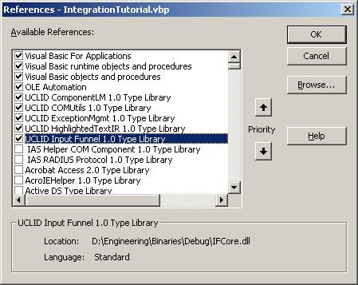

- Create the Input Funnel object (m_pInputFunnel). The Input Funnel manages input text received from a text file or image and directs it to the appropriate edit box. Create a TextBox object (m_pTextBox) to track the active edit box.

Option Explicit
' Defines Input Funnel object that handles input
Private WithEvents m_pInputFunnel As UCLID_INPUTFUNNELLib.InputManager
' Tracks active edit box
Private m_pTextBox As TextBox

- Add Input Funnel creation code to Form_Load().

Private Sub Form_Load()
On Error GoTo errHandler

' Initialize licensing
InitInputFunnelLicense

' Create new Input Funnel object

Set m_pInputFunnel = New InputManager
m_pInputFunnel.EnableInput1 "Text", "Please specify input", Nothing

' Set default input focus to Field1
Show
SetCurrentTextBox txtField1
Exit Sub

errHandler:
DisplayUCLIDException "ELI-Form_Load"
End Sub

- Add code for SetCurrentTextBox().

Private Sub SetCurrentTextBox(ByVal pTextbox As TextBox)
On Error GoTo errHandler

' If the field requested to be set as current is already
' the current field, then just exit.
If (Not m_pTextBox Is Nothing) Then
If (m_pTextBox Is pTextbox) Then

Exit Sub
End If
End If

' Set the new current text box
Set m_pTextBox = pTextbox
Exit Sub

errHandler:
DisplayUCLIDException "ELI-SetCurrentTextBox"
End Sub

- Add a New Text Window (cmdNewTextWindow) button.

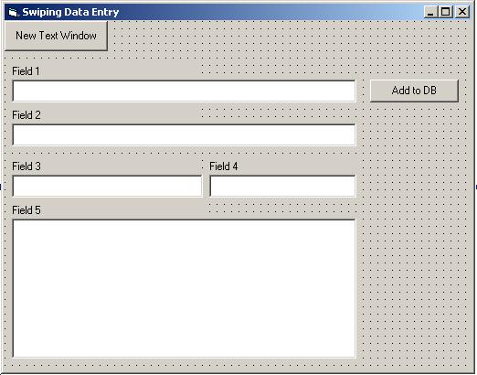

- Add code to handle the New Text Window button.

Private Sub cmdNewTextWindow_Click()
On Error GoTo errHandler

' Create a Highlighted Text Window
m_pInputFunnel.CreateNewInputReceiver "Highlighted Text Window"
Exit Sub

errHandler:
DisplayUCLIDException "ELI-cmdNewTextWindow_Click"
End Sub

- When the Input Funnel receives input, the text is placed in the highlighted text box. Add code for the NotifyInputReceived() event on the Input Funnel.

Private Sub m_pInputFunnel_NotifyInputReceived(ByVal pTextInput As UCLID_INPUTFUNNELLib.ITextInput)
On Error GoTo errHandler

' Handle notification that data was received by
' Input Funnel
If (Not m_pTextBox Is Nothing) Then
m_pTextBox.Text = pTextInput.GetText
End If
Exit Sub

errHandler:
DisplayUCLIDException "ELI-NotifyInputReceived"
End Sub

- Open a New Text Window and open the demo3.tif.txt file. Highlight some text, right-click and choose Send Text to provide the selected text to the Input Funnel. An example is shown below. Further details about how to use the Highlighted Text Window can be found here.

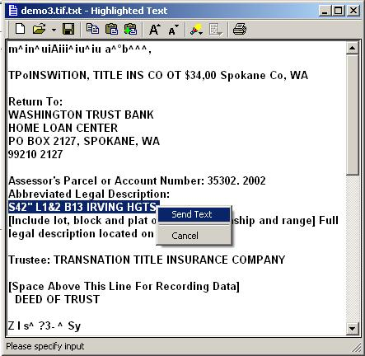

- Continue testing the application swiping data from the Highlighted Text Window. Note that swiped data currently appears only in Field 1. Also note that the original manual data entry capabilities remain.

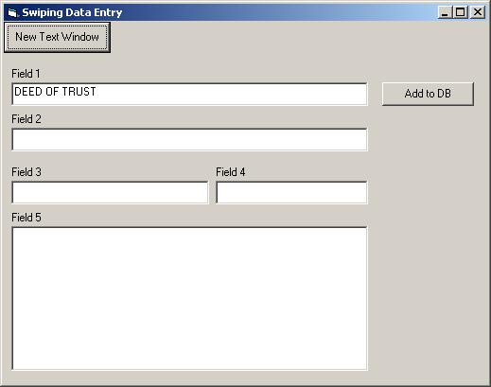

Part 2 – Add Image Swiping Functionality
This portion of the tutorial will add swiping functionality for image files. The swiped text will appear automatically in the first text box.

- Continue development from the end of the previous section. If the previous section has not been completed, copy the files from the Tutorials/Integration-Part1 folder into the Tutorials/Integration folder. Run the application and confirm that the Swiping Data Entry window appears with one toolbar button.

- Add a New Image Window (cmdNewImageWindow) button.

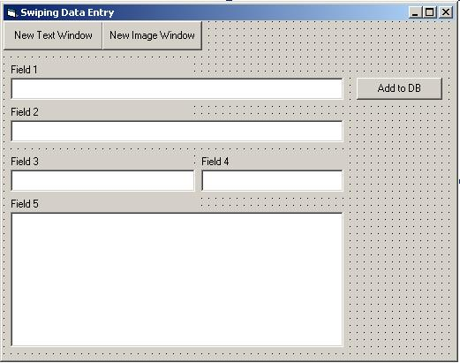

- Add the following UCLID COM objects to the collected References for the project.
- UCLID RasterAndOCRMgmt
- UCLID SpotRecognitionIR

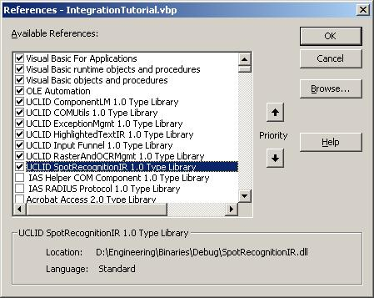

- Add code to handle the New Image Window button.

Private Sub cmdNewImageWindow_Click()
On Error GoTo errHandler

' Create a Spot Recognition Window
m_pInputFunnel.CreateNewInputReceiver "Spot Recognition Window"
Exit Sub

errHandler:
DisplayUCLIDException "ELI-cmdNewImageWindow_Click"
End Sub

- Open a New Image Window and open the demo1.tif file. Swipe some text to provide the selected text to the Input Funnel. An example is shown below. Further details about how to use the Spot Recognition Window can be found here.

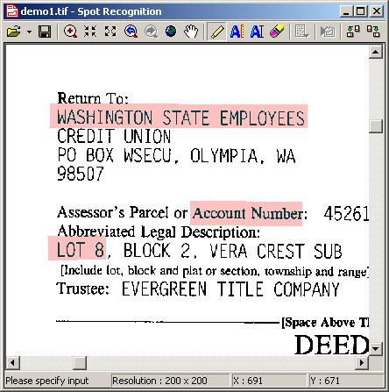

- Continue testing the application swiping data from the Spot Recognition Window. Note that swiped data currently appears only in Field 1. Also note that the original manual data entry capabilities remain.

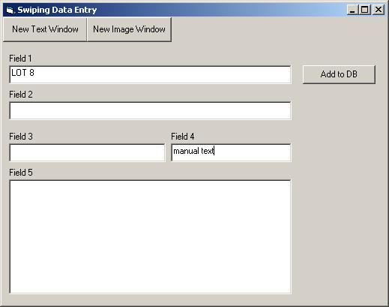

Part 3 – Add Automatic Text Box Advancement & Highlighting
This portion of the tutorial will add support for automatic advancement to the next text box plus highlighting of the selected text box.

- Continue development from the end of the previous section. If the previous section has not been completed, copy the files from the Tutorials/Integration-Part2 folder into the Tutorials/Integration folder. Run the application and confirm that the Swiping Data Entry window appears with two toolbar buttons.

- Modify SetCurrentTextBox() to support highlighting of the current text box.

Private Sub SetCurrentTextBox(ByVal pTextbox As TextBox)

On Error GoTo errHandler

' If the field requested to be set as current is already

' the current field, then just exit.

If (Not m_pTextBox Is Nothing) Then

If (m_pTextBox Is pTextbox) Then

Exit Sub

End If

End If

' Unhighlight the previously highlighted edit box

' if one such edit box exists

If (Not m_pTextBox Is Nothing) Then

m_pTextBox.BackColor = &H80000005

End If

' Set the new current text box

Set m_pTextBox = pTextbox

' Set focus to the new edit box and set yellow background color

If (Not m_pTextBox Is Nothing) Then

m_pTextBox.BackColor = &HFFFF&

m_pTextBox.SetFocus

End If

Exit Sub

errHandler:

DisplayUCLIDException "ELI-SetCurrentTextBox"

End Sub

- Add code for GotFocus() handlers for each of the five text boxes. The code below is only for Field2. Similar code is required for the other text boxes.

Private Sub txtField2_GotFocus()
On Error GoTo errHandler

' Move highlight to Field2
If (Not m_pTextBox Is txtField2) Then
SetCurrentTextBox txtField2
End If
Exit Sub

errHandler:
DisplayUCLIDException "ELI-txtField2_GotFocus"
End Sub

- Modify NotifyInputReceived() to call SetupNextInputField(). Also add the SetupNextField() method to automatically advance the active text box.

Private Sub m_pInputFunnel_NotifyInputReceived(ByVal pTextInput As UCLID_INPUTFUNNELLib.ITextInput)

On Error GoTo errHandler

' Handle notification that data was received by

' Input Funnel

If (Not m_pTextBox Is Nothing) Then

m_pTextBox.Text = pTextInput.GetText

SetupNextInputField

End If

Exit Sub

errHandler:

DisplayUCLIDException "ELI-NotifyInputReceived"

End Sub

Private Sub SetupNextInputField()

On Error GoTo errHandler

' Move focus from Field1 to Field2

If (m_pTextBox Is txtField1) Then

SetCurrentTextBox txtField2

' Move focus from Field2 to Field3

ElseIf (m_pTextBox Is txtField2) Then

SetCurrentTextBox txtField3

' Move focus from Field3 to Field4

ElseIf (m_pTextBox Is txtField3) Then

SetCurrentTextBox txtField4

' Move focus from Field4 to Field5

ElseIf (m_pTextBox Is txtField4) Then

SetCurrentTextBox txtField5

' Move focus from Field5 to Nothing

ElseIf (m_pTextBox Is txtField5) Then

SetCurrentTextBox Nothing

End If

Exit Sub

errHandler:

DisplayUCLIDException "ELI-SetupNextInputField"

End Sub

- Test the application by opening both a text file (demo3.tif.txt) and an image file (demo1.tif) and swiping text from each. An example is shown below.

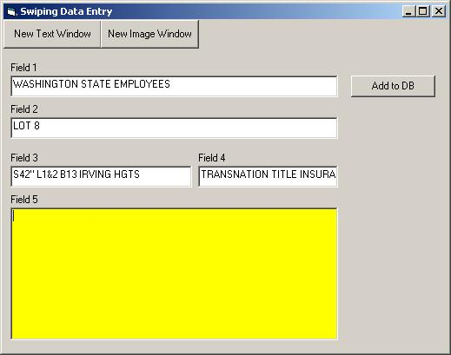

Part 4 – Add Multiple Line Support
This portion of the tutorial will add support for multiple lines of input text from either a Text Window or an Image Window. The first seven items implement multiple-line support for data from an Image Window. The last five items add multiple-line support for data from a Text Window.

- Continue development from the end of the previous section. If the previous section has not been completed, copy the files from the Tutorials/Integration-Part3 folder into the Tutorials/Integration folder. Run the application and confirm that the Swiping Data Entry window appears with two toolbar buttons and a yellow highlight in the first text box.

- Add a statement to the form declarations to implement paragraph text handling.

' Allows Form to accept and manage a block of text from

' Spot Recognition Window
Implements UCLID_SPOTRECOGNITIONIRLib.IParagraphTextHandler

- Add code for paragraph text handling. The GetPTHDescription() method provides a string that is displayed in the Spot Recognition Window status bar as a user prompt. The IsPTHEnabled() method allows a paragraph of text to be accepted as input only for specific locations. In this situation, the handler is always enabled because a paragraph of text is always directed to Field5. The NotifyParagraphTextRecognized() method directs the input to Field5 regardless of the current active text box.

Private Function IParagraphTextHandler_GetPTHDescription() As String
On Error GoTo errHandler

' Set description of Paragraph Text Handler to be
' selection of Field5 data
IParagraphTextHandler_GetPTHDescription = "Select '" & txtLabel5 & "' "
Exit Function

errHandler:
DisplayUCLIDException "ELI-GetPTHDescription"
End Function

Private Function IParagraphTextHandler_IsPTHEnabled() As Boolean
On Error GoTo errHandler

' Paragraph Text Handler is enabled for data in Field5
IParagraphTextHandler_IsPTHEnabled = True
Exit Function

errHandler:
DisplayUCLIDException "ELI-IsPTHEnabled"
End Function

Private Sub IParagraphTextHandler_NotifyParagraphTextRecognized(ByVal pSourceSRWindow As UCLID_SPOTRECOGNITIONIRLib.ISpotRecognitionWindow, ByVal pText As UCLID_RASTERANDOCRMGMTLib.SpatialString)
On Error GoTo errHandler

' Handle notification that data was received by
' Paragraph Text Handler into Field5
SetCurrentTextBox txtField5
txtField5 = pText.String
SetupNextInputField
Exit Sub

errHandler:
DisplayUCLIDException "ELI-NotifyParagraphTextRecognized"
End Sub

- Modify cmdNewImageWindow_Click() to include support for Paragraph Text Handling.

Private Sub cmdNewImageWindow_Click()
On Error GoTo errHandler

' Create a Spot Recognition Window
Dim nIRID As Long
nIRID = m_pInputFunnel.CreateNewInputReceiver("Spot Recognition Window")

' Save pointer to the SRIR
Dim pSRW As ISpotRecognitionWindow
Set pSRW = m_pInputFunnel.GetInputReceiver(nIRID)

' Create collection of Paragraph Text Handlers
Dim pPTHs As New IUnknownVector

' Add self to collection
pPTHs.Push_back Me

' Associate collection of handlers with SRIR object
pSRW.SetParagraphTextHandlers pPTHs
Exit Sub

errHandler:
DisplayUCLIDException "ELI-cmdNewImageWindow_Click"
End Sub

- Open a New Image Window and open the demo1.tif file. Swipe some text to fill in some items on the form. Click the Process toolbar button and select the Process Rectangular area menu item.

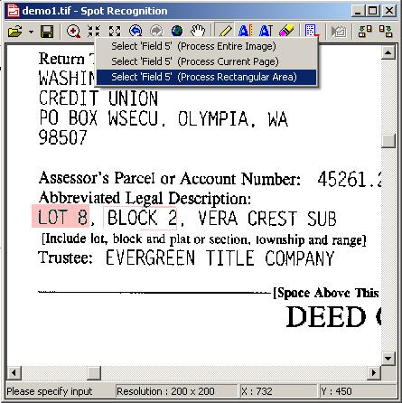

- Use the mouse to define a rectangular region around the return address.

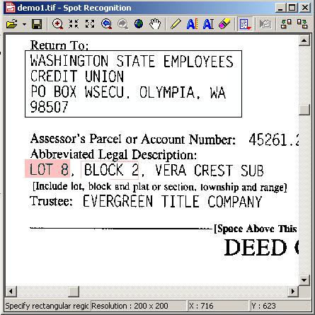

- Notice that the recognized text has appeared in the last text box.

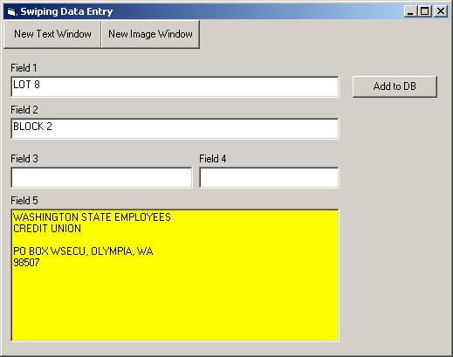

- Add a statement to the form declarations to implement text processing.

' Allows Form to accept and manage a block of text from
' Highlighted Text Window
Implements UCLID_HIGHLIGHTEDTEXTIRLib.IHTIRTextProcessor

- Modify the code in cmdNewTextWindow_Click() to support Text Processing.

Private Sub cmdNewTextWindow_Click()
On Error GoTo errHandler

' Create a Highlighted Text Window
Dim nIRID As Long
nIRID = m_pInputFunnel.CreateNewInputReceiver("Highlighted Text Window")

' Save pointer to the HTIR
Dim pHTW As IHighlightedTextWindow
Set pHTW = m_pInputFunnel.GetInputReceiver(nIRID)

' Create collection of Text Processors
Dim pTPs As New IUnknownVector

' Add self to collection
pTPs.Push_back Me

' Associate collection of processors with HTIR object
pHTW.SetTextProcessors pTPs
Exit Sub

errHandler:
DisplayUCLIDException "ELI-cmdNewTextWindow_Click"
End Sub

- Add code for text processing. The GetTPDescription() method provides a string that is displayed in the Highlighted Text Window menu as a user prompt. The IsTPEnabled() method allows a block of text to be accepted as input only for specific locations. In this situation, the handler is always enabled because a block of text is always directed to Field5. The ProcessText() method directs the input to Field5 regardless of the current active text box.

Private Function IHTIRTextProcessor_GetTPDescription() As String
On Error GoTo errHandler

' Set description of Text Processor to be
' selection of Field5 data
IHTIRTextProcessor_GetTPDescription = "Select '" & txtLabel5 & "' "
Exit Function

errHandler:
DisplayUCLIDException "ELI-GetTPDescription"
End Function

Private Function IHTIRTextProcessor_IsTPEnabled() As Boolean
On Error GoTo errHandler

' Text Processor is enabled for data in Field5
IHTIRTextProcessor_IsTPEnabled = True
Exit Function

errHandler:
DisplayUCLIDException "ELI-IsTPEnabled"
End Function

Private Sub IHTIRTextProcessor_ProcessText(ByVal strText As String)
On Error GoTo errHandler

' Handle block of text received by Text Processor
' into Field5
SetCurrentTextBox txtField5
txtField5 = strText
SetupNextInputField
Exit Sub

errHandler:
DisplayUCLIDException "ELI-ProcessText"
End Sub

- Open a New Text Window and open the demo3.tif.txt file. Select and send some text to fill in some items on the form. Click the Process Text toolbar button and select the Process Entire Text menu item.

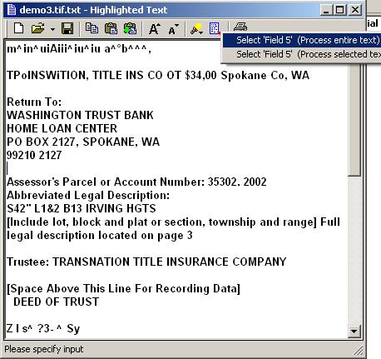

- Notice that the recognized text has appeared in the last text box.

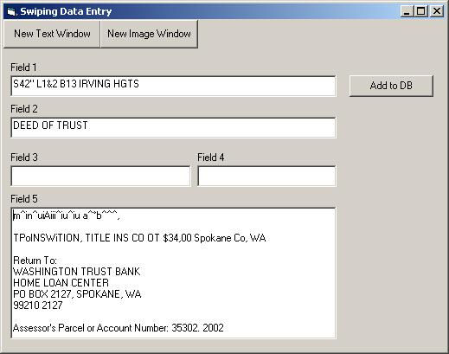

Further Efforts
This portion of the tutorial will describe additional exercises available to the student.

- Create a simple database and add connection and update code to cmdSubmit_Click().

- Integrate the Load Settings functionality from the Automated Data Entry tutorial to modify text box labels.

- Integrate the Find Data functionality from the Automated Data Entry tutorial to allow automated data entry.

